Dis-Haida Two-Headed Thunderbird Body Stamp-19th century

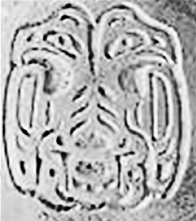

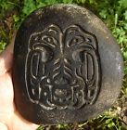

Fig. 1**:** Haida Two-Headed Thunderbird Body Stamp-19th century; Fig. 2. Same but gray tone and inverted.

**Formal Label:** Haida Two-Headed Thunderbird Body Stamp-19th century

**Accession Number:**

**LC Classification:** E78.N78

**Date or Time Horizon:** Late 19th century

**Geographical Area:** Northwest Coast

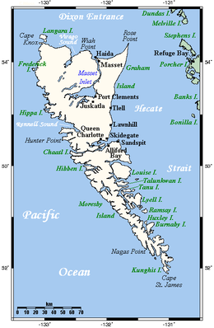

**Fig. 3. Map of Queen Charlotte Islands After https://upload.wikimedia.org/wikipedia/commons/thumb/c/c1/Queen_Charlotte_Islands_Map.png/390px-Queen_Charlotte_Islands_Map.png**

**Cultural Affiliation:** Haida

**Medium:** Sandstone

**Dimensions:   
Weight:**

**Provenance: Haida Skidegate Village, British Columbia**

**Condition**: Used as a body stamp with charcoal still adhering to surfaceDiscussion: Each dancing society hadits own distinctive features.

Some societies were the exclusive right of particular village chiefs and not widely distributed on Haida Gwaii. literally "Islands of the Haida people"), formerly known as the Queen Charlotte Islan**ds**, is an archipelago on the North Coast of British Columbia, Canada.

John Reed Swanton and Edward S. Curtis interviewed many informants after the passing of the societies so that they revealed some facts that otherwise would have been kept secret when the societies were active. Swanton (1975, i.e. 1909: 160) claimed that the secret societies were merged with shamanic beliefs of the Haida: ”Just as a shaman was supposed to be inspired by some supernatural being who "spoke," or, as they generally preferred to translate it to me, "came through" him, so the U'lala spirit, the Dog-eating spirit, the Grisly-Bear spirit, and so on, "came through" the secret-society novice *.*”

One of the main societies was the U’lala, similar to the Hamatsa (or Cannibal) among the Kwakiutl, which was danced only by men. A long pole with a crossbar projected through the roof from behind the dance curtain and had cedar bark streamers suspended from it. This pole was rotated to signal to those outside that the U’lala was about to emerge. According to Curtis (1972, 11: 145), "Various masks were worn by U’lala, depending on the supposed source of his supernatural power." Also body stamps were used in a similar way to mark the entrance of the spirit of a potent animal master, the envisioned source of the dancer’s spiritual power.

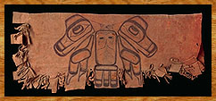 

Fig. 4.**:** Haida Two-Headed Thunderbird on surface of a deerskin bag, Royal Canadian Museum of Civilisation, VII-B-538 (S92-4235). Fig. 5. Body stamp for comparison.

The deerskin bag (Fig. 4.), which held powdered red ochre for body paint, was used in a variety of ceremonies including the U’lala. The double-headed Thunderbird on its front is a rarity among the Haida, who usually portray it with a single head, and it is similar *in structure* to the tattoo design on the sandstone body stamp.

**References:**

[Swanton](https://www.google.com/search?tbo=p&tbm=bks&q=inauthor:%22John+Reed+Swanton%22), John Reed. 1975, i.e. 1909. *Contributions to the Ethnology of the Haida*. New York: AMS Press.

### Curtis, Edward S. 1972. *Portraits from North American Indian life.* New York: Outerbridge & Lazard, Vol. 11.